PROJECT REPORT

DIGITAL MARKETING (Naan Mudhalvan)

**TITLE:** CONTENT MARKETING

**NAAN MUDHALVAN GROUP ID:** NM2023TMID03502

**TEAM MEMBERS:**

1. Sanmathi. B (Team Leader) Reg.no: 810020106013

2.Baby Sharmila. S Reg.no: 810020106008

3. Bhagyalakshmi. U Reg.no: 810020106010

4.Nithishkumar. S Reg.no: 810020106704

**INTRODUCTION:**

Content Creation is the spine of our entire digital marketing strategy. Whether we’ve got a documented content marketing strategy or not, we’re creating content to inform, entertain, inspire, or persuade our buyers through other channels. some content marketing examples include:

* Blog posts
* Emails
* Newsletters
* Social media posts
* Podcasts
* EBooks
* Videos

**PROJECT OVERVIEW:**

The Boutique shop that we are promoting is ‘CLOSET LUXE’ which is a unique clothing store. We know for sure now a day’s people are very cautious about what they wear and how they appear. So, from our passion and love for the wonderful world of fashion we have come up with our unique boutique store which we believe will is pleasing our customers. Our boutique store focuses on the establishment of women wear including the operations of apparel designing, manufacturing, selling and marketing. We have developed some unique ways to attract customers and believe our customers as the hero of our small boutique store.

**Content Marketing plan:**

Content marketing plan is the documented strategy that details the who, what, when, where, why & how of our content.

* **Who** is creating the content?
* **What** kind of content?
* **When** is the content being published?
* **Where** is the content being distributed
* **Why** are you even content marketing?
* **How** are promoting and analysing the marketing results?

**CONTENT MARKETING STRATEGY:**

A content marketing strategy helps you achieve specific goals, define clear success metrics, and create processes for specific improvement.



**BENEFITS OF CONTENT MARKETING PLAN:**

* **More online visibility**: The more consistently you post, the more customers you can attract. Provide educational, useful content that addresses users’ pain points.
* **More leads**: Because a good content marketing strategy drives traffic, it can also drive leads
* **More authority**: The more useful content you share over time, the more people in your niche will see you as an authority figure
* **More customer engagement**: Loyal customers are often repeat customers. Engage with those who comment or respond to what you share.
* **More budget**: If you can prove your marketing success, it will likely be easier to ask for a bigger marketing budget in the future

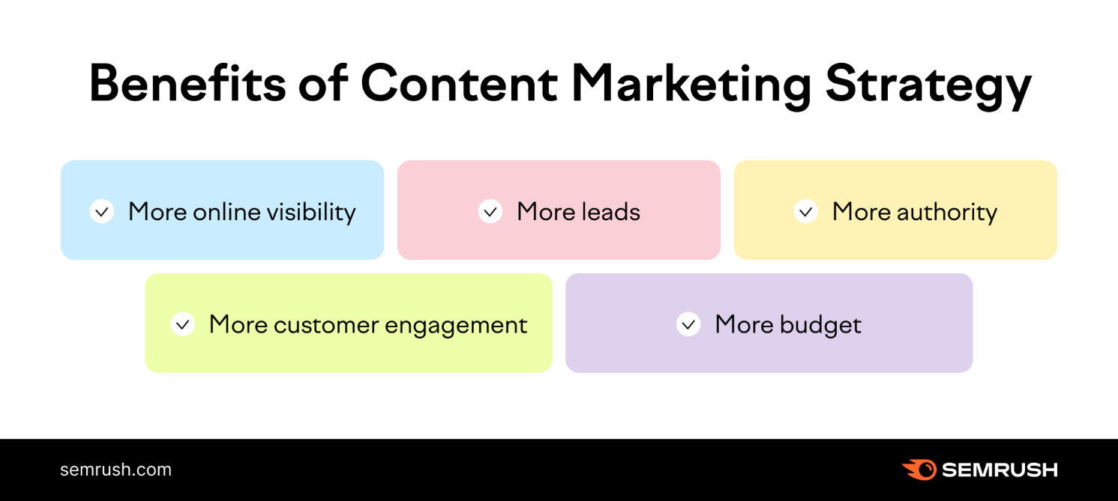

**5 ELEMENTS OF POWERFUL CONTENT MARKETING STRATEGY:**

An effective content marketing strategy should have these five core elements to be successful:

1. Audience [personas](https://www.semrush.com/blog/buyer-persona/?utm_source=StrategyPost&utm_medium=link&utm_campaign=CMplatform19)
2. Brand story
3. Content marketing mission
4. Business case
5. An action plan

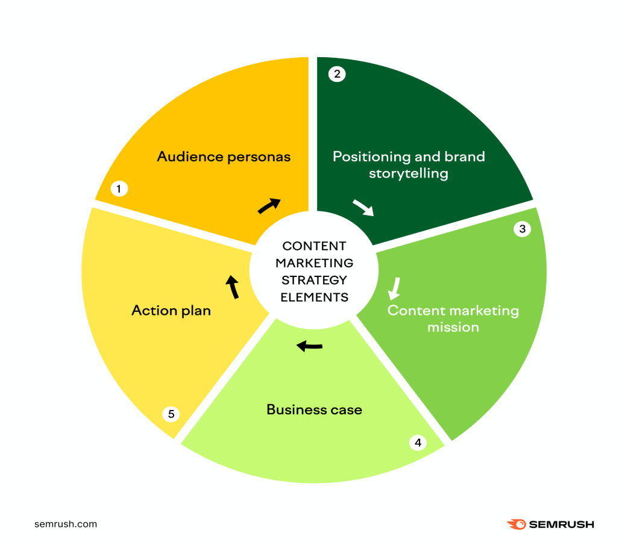

**EMPATHY MAP:**

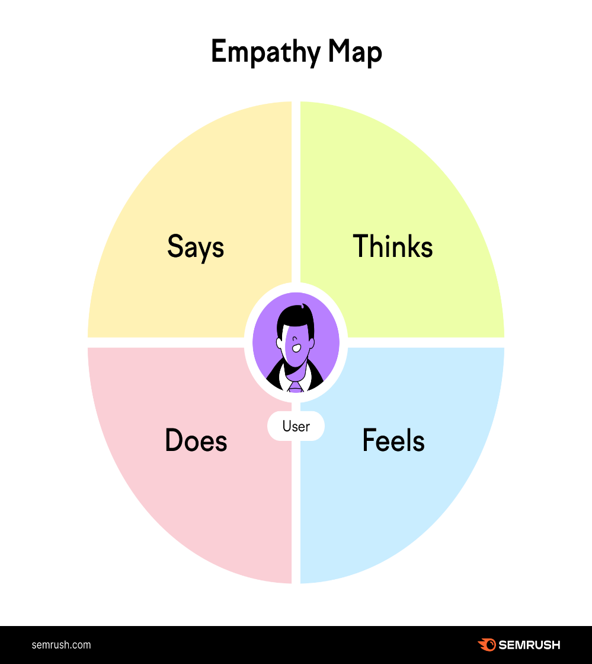

**Diversify Your Content:**

The ideal solution is to include a diverse mix of content formats to appeal to every member of your audience. Your selection will depend on your customers’ preferences and your analysis of content performance.

This graphic breaks down a few options you might want to include in your content strategy:

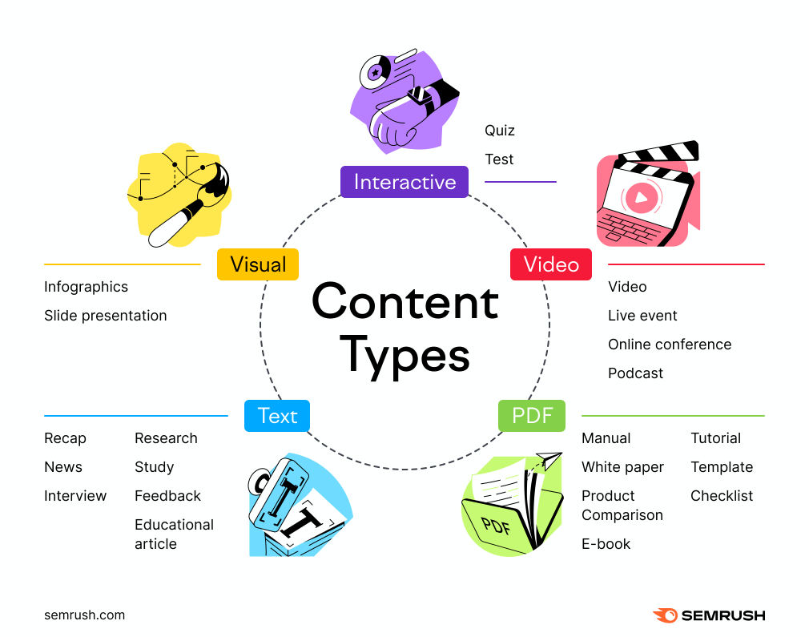

**STEPS INVOLVED IN MAKING CONTENT MARKETING TEMPLATE:**

**1.CREATE A LOGO FOR BUSINESS:**



**2. CREATE BLOG :**

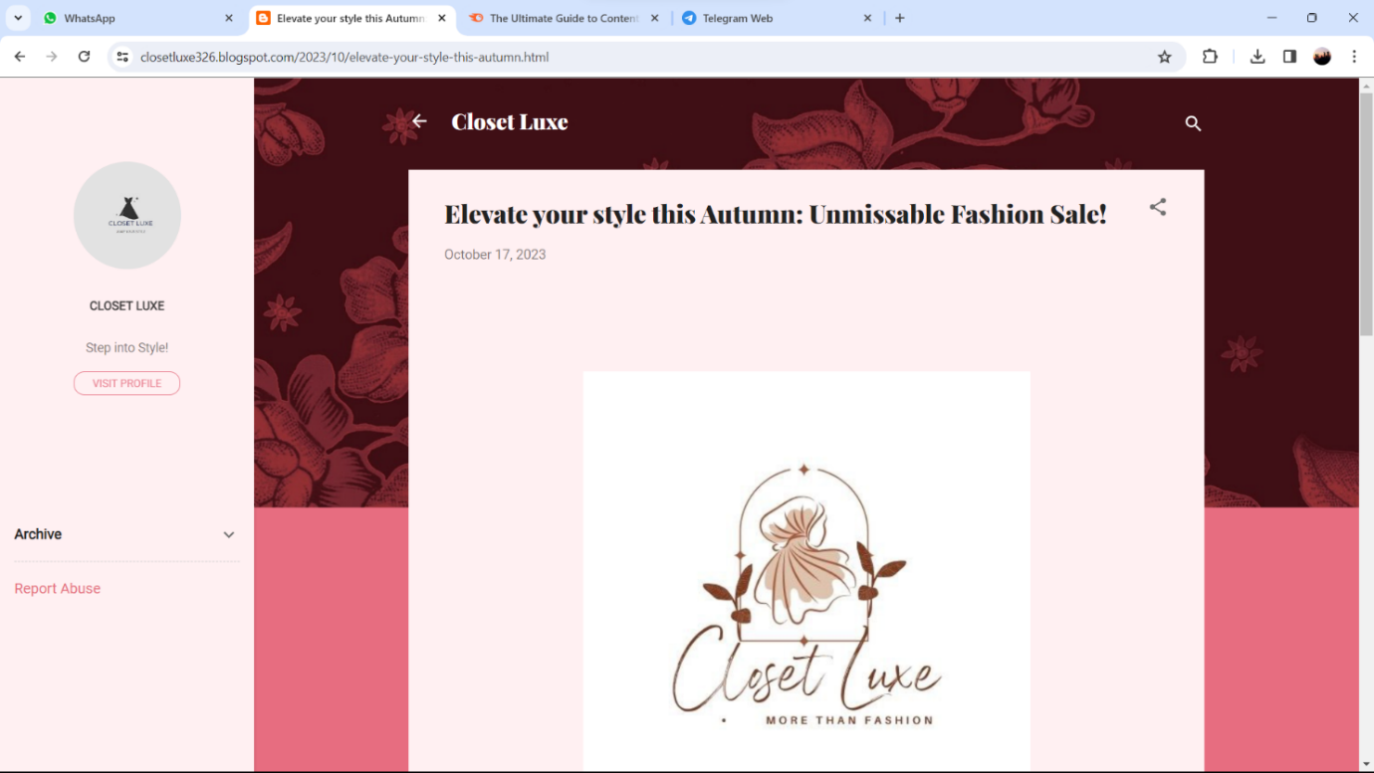

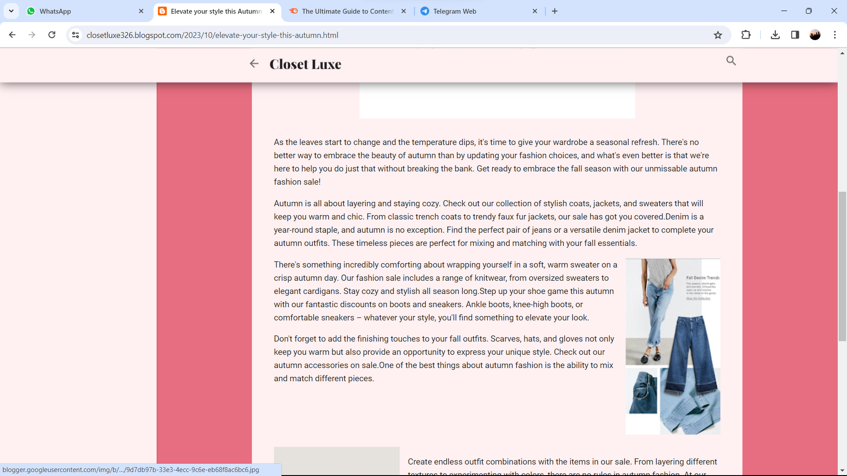

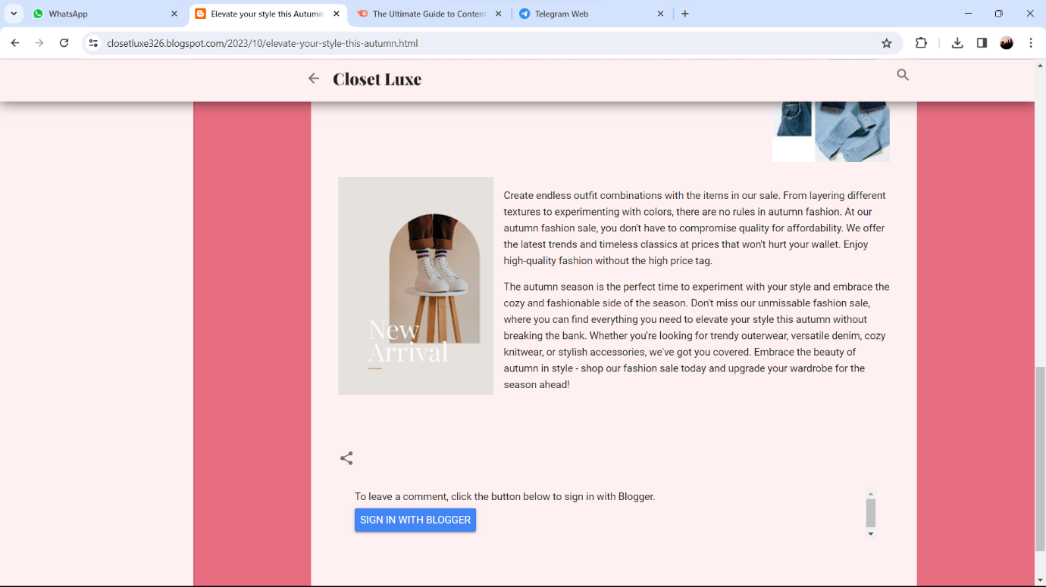

**3. CREATE SOCIAL MEDIA PAGE(INSTAGRAM):**

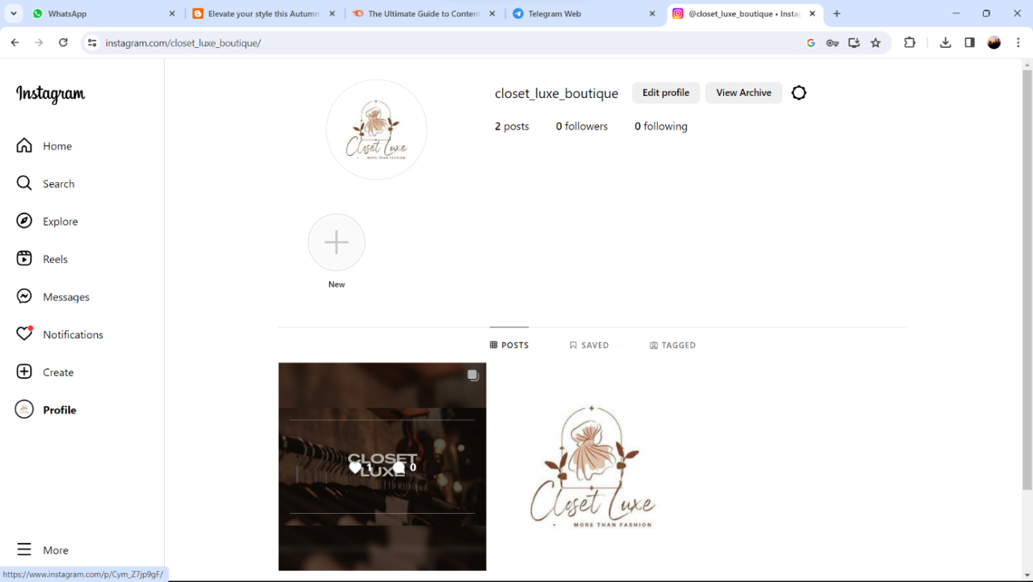

**4. CREATE YOUTUBE CHANNEL ACCOUNT:**

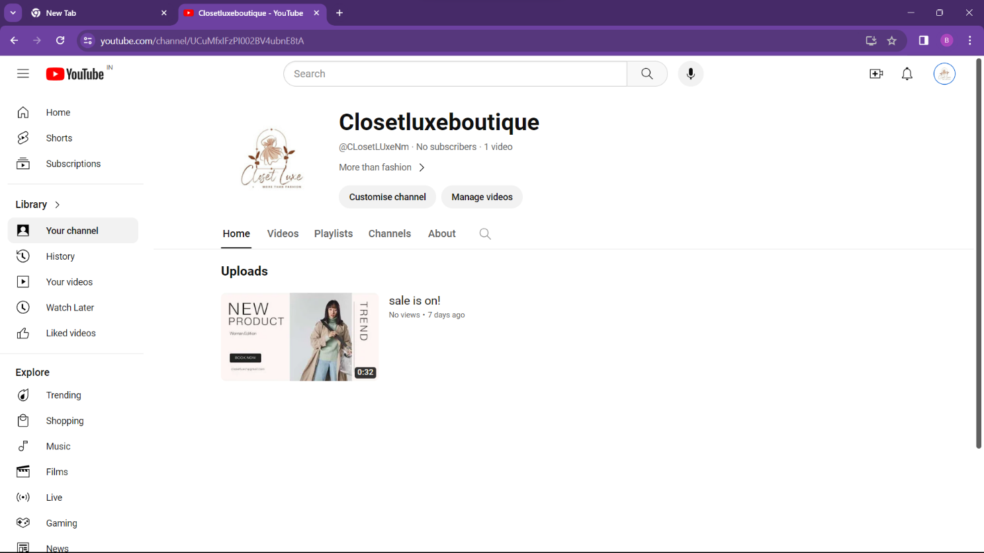

**CONCLUSION:**

Content marketing builds customer awareness, generates leads, and increases conversions. With the advancement of the digital age, content has become an essential part of any marketing strategy. There will always be strategies that generate quick, short-term returns, but content marketing has the potential to increase your business's effectiveness for years to come. A well-executed content marketing campaign can save your digital marketing efforts.

**PROJECT DETAILS:**

**PROJECT TITLE:** CONTENT MARKETING

**NAAN MUDHALVAN GROUP ID:** NM2023TMID03502

**TEAM MEMBERS:**

1. Sanmathi. B (Team Leader) (NM ID: 9E8AA4C3CF42FC9846C4F19641A93154)

2.Baby Sharmila.S (NM ID: AABD6A2B5A1DB37B7614E07B252F4061)

3.Bhagyalakshmi. U (NM ID: 67371C10E08CB0E830346A83BD8CD157)

4.Nithishkumar. S (NM ID: 861E1DCD45F9B23A7A949E0CC0C6BACF)

**GITHUB LINK:**

<https://github.com/Closetluxe/NaanMudhalvan_Digital-marketing_Content-marketing.git>

**DEMO LINK:**

<https://drive.google.com/file/d/1IXfXI2jkURb8ywxZiYCwM1ZdX8VLWog_/view?usp=drivesdk>

**AD VIDEO LINK:**

<https://youtu.be/3mM641UiiQA?si=1aZtKrvUpeYilU53>

**INSTAGRAM PAGE LINK:**

<https://instagram.com/closet_luxe_boutique?igshid=YTQwZjQ0NmI0OA==>

**BLOG LINK:**

<https://closetluxe326.blogspot.com/>